- CloudFront is AWS's Content Delivery Network (CDN) service.
Think of it as a network of servers located around the world that cache your website's content closer to users, making it load faster and reducing load on your origin server.

Without CloudFront
Suppose your website is hosted on an EC2 instance in Mumbai.
User (USA)
|
| Request
v
EC2 Instance (Mumbai)
Every user, regardless of location, must connect all the way to Mumbai.

With CloudFront
User (USA)
|
v
CloudFront Edge Location (USA)
|
v
EC2 Instance (Mumbai)
CloudFront caches content at nearby edge locations. Users get data from the closest edge server instead of your origin every time.
- Practical of cloudfront
Step 1: Launch 1 website in ec2.
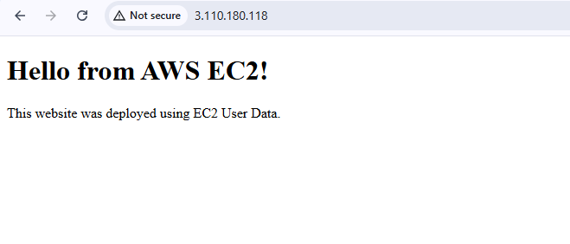
Right click and go to inspect and see the info
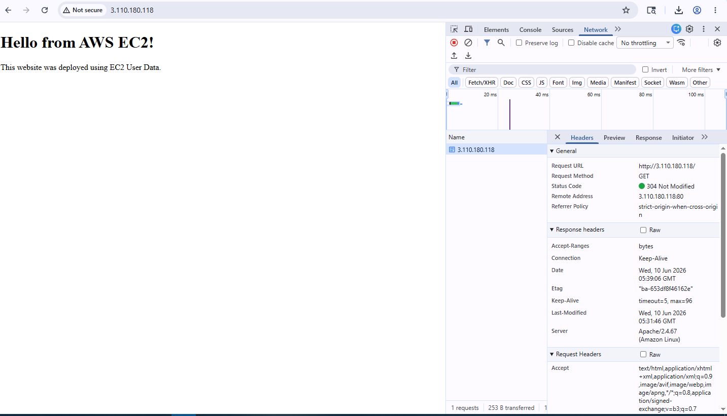
Now go to the cloudfront and create distribution
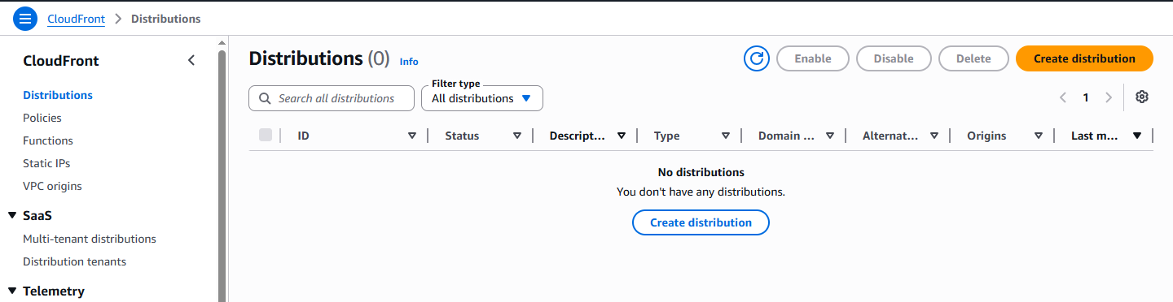
Give name to cloudfront
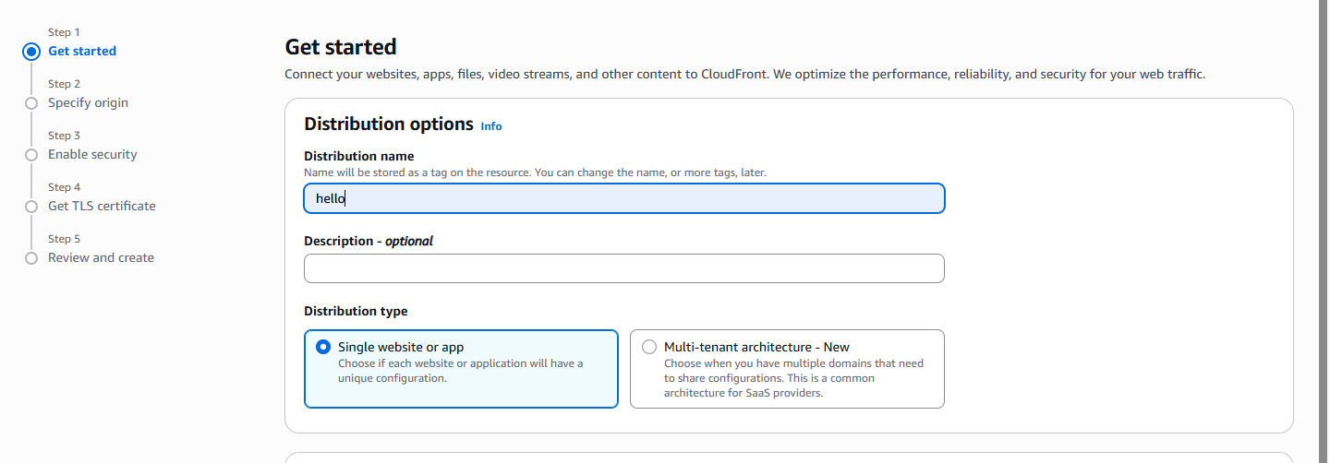
Select the ec2 as a origin type using ec2 public dns.
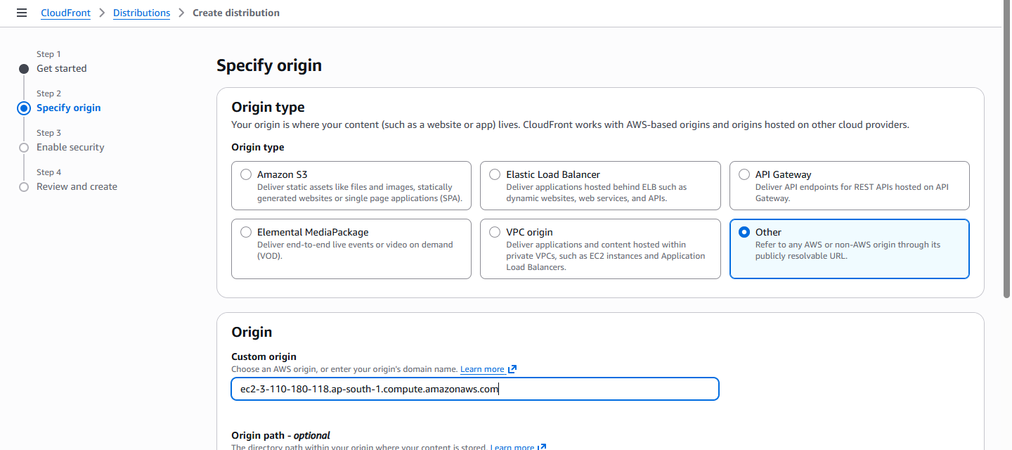

And don’t select the waf.
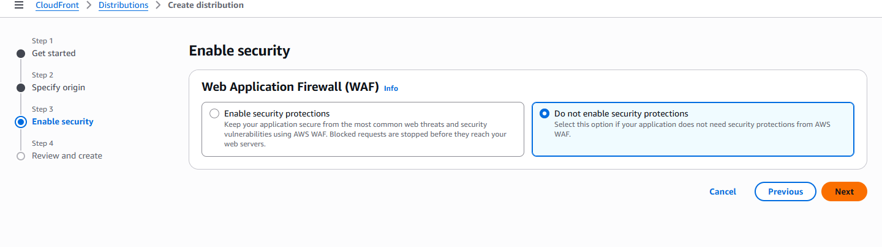
After creation go to origin select the created origin and click on edit.

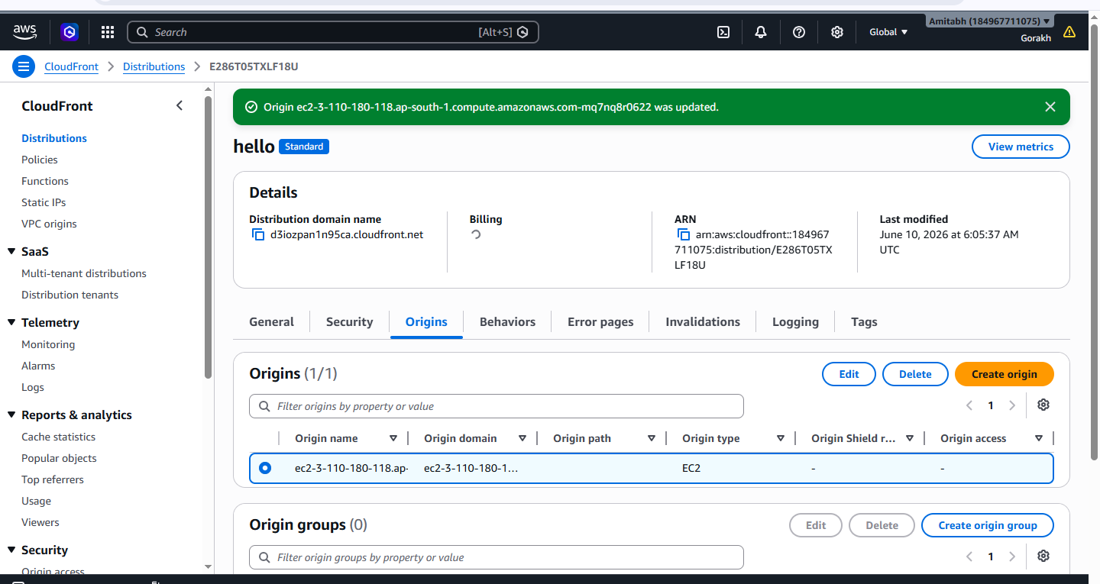
Select http only and save
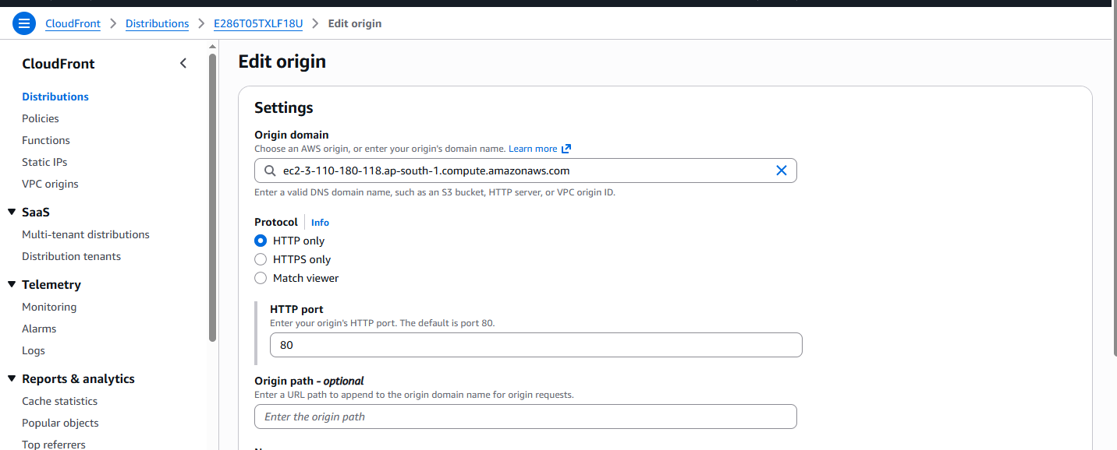
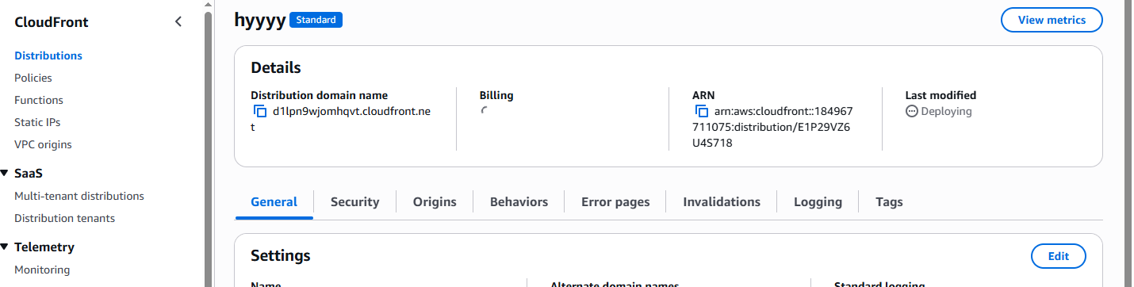

Take cloudfront dns and paste it to the browser then you can see the ec2 website using cloudfront and that you can verify in inspect-“hit from cloudfront”.
